A: Natural selection and Evolution
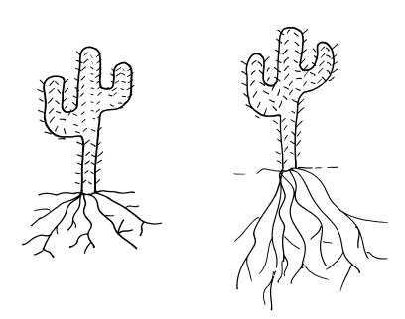
- Cacti are normally found in arid habitats where water is scarce and day temperatures are high.
After a period of 10 years of drought in an area, researchers discovered that the mean length of roots in a cactus population had increased.
In the 1800s, Darwin and another scientist called Lamarck had different theories to explain how the short roots of the cactus evolved into the longer present day roots of the cactus.
Lamarck had an idea that the root cells would have stretched during the lifetime of the cactus to reach more water. The stretched roots would then be passed on to the offspring.
- Explain Darwin’s theory of natural selection to explain how longer roots evolved. (4)
- Suggest one reason why scientists in the 1800s could not decide if Darwin or Lamarck was correct. (1)
- The general public in the 1800s had a different idea which explained how all life on Earth came about. What was this idea? (1)
- Describe three reasons why Darwin’s theory of evolution by natural selection has now been widely accepted by everyone. (3)
- Explain how working with bacteria and antibiotics has helped scientists learn more about evolution. (4)
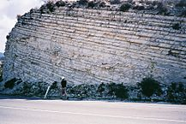
- Stratigraphy is a scientific study of rock layers (strata) and how they are layered.
a) How could this knowledge be used in supporting evidence for human evolution? (3)
b) Why might this evidence not be accurate? (1)
c) Give three reasons why scientists concluded that Lucy (Australopithecus afarensis) was more human like than Ardi (Ardipithecus ramidus). (3)
d) A bat and a whale have both been found to have pentadactyl limb structures. Why is this an important piece of evidence for evolution? (2)

B: Classification of living organisms
- a) Both of the birds in the photograph are known as robins. Suggest two reasons why this could be a problem. (2)
Turdus migratorius

Erithacus rubecula
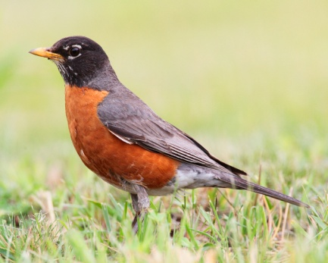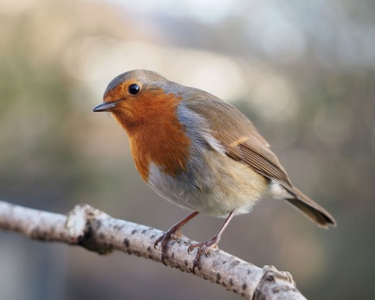
- What information do the scientific names of the robins provide? (2)
- Why can it be difficult to classify some living organisms? (2)
Carl Woese identified three distinct groups of organisms he called domains: Archaea, Bacteria and Eukaryota.

Feature | Archaea | Bacteria | Eukaryota
Type of chromosome | Circular | Circular | Linear
Number of protein molecules in RNA polymerase | 10 | 5 | 12
Cell membrane | Branched hydrocarbon chains attached to glycerol by ether bonds | Unbranched fatty acid chains attached to glycerol by ester bonds | Unbranched fatty acid chains attached to glycerol by ester bonds
Peptidoglycan present | No | Yes | Yes
Size of ribosomes | 70S | 70S | 80S
- Using the information in the table, give evidence that agrees with Carl Woese’s theory that archaea should be grouped separately to bacteria and eukaryota. (2)
- Woese put forward this simple evolutionary tree to show the relationships between the three domains. What has happened at points A and B on the diagram? (2)
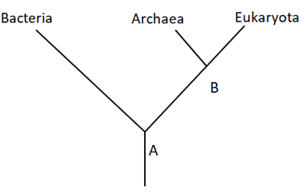

- Which two domains are most closely related according to Woese? (1)
C: Selective breeding, tissue culture and genetic engineering
- Explain how the human insulin gene and plasmids can be used to genetically modify bacteria. (4)
Rubbish-filled ditch beside roadside burger van named as one of UK’s 10 most important wildlife sites. Daily Mail.co.uk Feb 1, 2011.

2

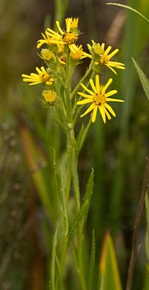
Extended response question
According to Natural England this is the only place in the country where self seeded Fen Ragwort grows. It was thought to have become extinct in the Victorian era.
Describe the benefits and disadvantages to tissue culture being used to preserve the species. (6)

- The photographs show a wild pig and a modern day pig known as the Large White.
The Large White is a descendant of the wild pig and has been produced by selective breeding. It is renowned for bacon production. The photographs are scaled to show the relative sizes.
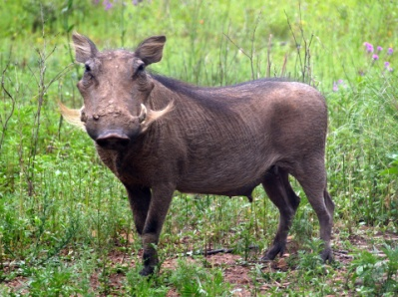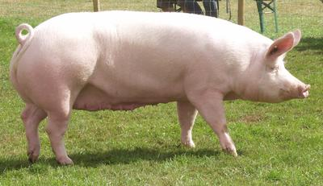
- Suggest two features you can see in the photograph that farmers selected for when breeding the Large White. (2)
- Explain how a farmer could use selective breeding to breed pigs which are very docile in nature. (3)

